**The Global Burden of Maternal Bereavement:**

**Indicators of the Cumulative Prevalence of Child Loss**

**Abstract**

**Background** We provide country-level estimates of the cumulative prevalence of mothers bereaved by a child’s death in 170 countries and territories.

**Methods** We generate indicators of the cumulative prevalence of mothers who have had an infant, under-five-year-old, or any-age child ever die by using publicly available survey data in 89 countries and an indirect approach that combines formal kinship models and life table methods in an additional 81 countries. We label these measures the maternal cumulative prevalence of infant mortality (mIM), under-five mortality (mU5M), and offspring mortality (mOM) and generate prevalence estimates for 20-44-year-old and 45-49-year-old mothers.

**Results** In several Asian and European countries, the mIM and mU5M are below 10 per 1000 mothers yet exceed 200 per 1000 mothers in several Middle Eastern and African countries. Global inequality in mothers’ experience of child loss is enormous: mothers in high-mortality-burden African countries are more than 100 times more likely to have had a child die than mothers in low-mortality-burden Asian and European countries. In more than 20 African countries, the mOM exceeds 500 per 1000 mothers, meaning that it is typical for a surviving 45-49-year-old mother to be bereaved.

**Discussion** The study reveals enormous global disparities in mothers’ experience of child loss and identifies a need for more research on the downstream mental and physical health risks associated with parental bereavement.

**Key questions**

**What is already known?**

● In sub-Saharan African countries, maternal indicators of the child mortality burden show that—even as infant and child mortality rates decline—having experienced a child’s death remains a common maternal experience.

● Child death is known to adversely affect mothers’ lives, yet we lack a systematic, global analysis of the maternal prevalence of child loss.

**What are the new findings?**

● Our results offer estimates of the maternal cumulative prevalence of infant (mIM), under-five (mU5M), and all offspring mortality (mOM) for 20-44-year-old and 45-49-year-old mothers in 170 countries, providing a new view of the burden of premature death across the globe.

● Global inequality in mothers’ experience of child death is enormous: mothers in select African countries are more than 100 times more likely to have had a child die than mothers in select Asian or European countries.

**What do the findings imply?**

● Quantifying maternal experiences of child loss offers a new sense of the population burden of child death, reveals how disparate maternal conditions are worldwide, and attests to the need for additional individual-level research on the consequences of child loss for families.

**BACKGROUND**

Infant and child mortality rates have declined worldwide over the last fifty years, signifying notable progress for children and their parents.1 Reductions in annualized rates of infant and child mortality, however, cannot reasonably proxy parents’ cumulative experiences of child loss, a phenomenon we refer to as *parental bereavement*. A child’s death can have serious and long-lasting consequences for parents2–4, but the population prevalence of bereaved parents has only been estimated for a select group of countries in sub-Saharan Africa.5 From those estimates, as recently as 2015, over one-third of mothers in sub-Saharan Africa had experienced a child death.5 It remains unclear whether such high levels of maternal bereavement characterize other low- and middle-income countries and how this burden compares to high-income countries.

In this article, we offer a global perspective on maternal bereavement by providing the first population-level estimates of the prevalence of bereaved mothers in 170 countries. We generate three indicators of the cumulative prevalence of mothers who have had an infant, under-five year old, or any-age child die. We label these indicators: the maternal cumulative prevalence of infant mortality (mIM), under-five mortality (mU5M), and offspring mortality (mOM).5 We calculate these measures separately for two groups of mothers: those in the peak of their reproductive years (20-44-year-old mothers) and those nearing the end of their reproductive careers (45-49-year-old mothers). To achieve global coverage, we generate these indicators through a combination of direct estimation, using publicly available survey data, and an indirect-estimation strategy using publicly available age-specific fertility and mortality schedules.6

Population-level measures of maternal bereavement summarize how infant, child, and adolescent mortality conditions accumulate, forming a corresponding shadow population of bereaved parents deserving of public health attention. Global inequalities in the burden of family bereavement reflect disparate health environments and may also compound disadvantage by leaving parents vulnerable to the grief, trauma, and other adverse outcomes associated with bereavement.7–11 A child’s death can have profound and lasting influence on parents’ wellbeing, including their mental health, physical health, and longevity.2–4,12–20 The health consequences associated with bereavement are especially severe for mothers, and the adverse effects of grief can persist for years—even decades.16 Child loss can also adversely impact other aspects of parents’ lives, including the health and stability of the union.3,18 The guilt, blame, stigma, stress, and relationship strain associated with child loss has been documented across diverse cultural contexts, including in settings where child loss is tragically common and perhaps, even, an anticipated, aspect of motherhood.21–25 By demonstrating the size and distribution of child loss across the globe, these metrics render visible an inequity that has been overlooked in the global health literature.

In offering a global overview of maternal bereavement, our study also clarifies that a population’s parental bereavement burden cannot be inferred from current mortality indicators because it is patterned by both past and present mortality and fertility conditions. In terms of mortality: a legacy of higher child and adolescent mortality years earlier will linger in the birth histories of older mothers, contributing to higher lifetime experiences of bereavement. Past and present death rates dictate not just the likelihood of losing a child but also how many bereaved mothers have survived versus how many died prematurely, thereby erasing their experience of child loss. The degree to which child deaths are dispersed across families versus concentrated among a disadvantaged few further shapes the total societal reach of these experiences. On fertility: a parents’ cumulative risk of experiencing a child die is determined by exposure, specifically the number of children she has.26 Thus, this worldwide portrait of maternal bereavement offers a fundamentally new perspective on the global-health landscape.

**METHODS**

**Data sources**

Survey-based Estimates of Maternal Bereavement

We generate indicators of the maternal cumulative prevalence of child death directly using microdata from nationally representative surveys that collect full reproductive histories from female respondents. To expand country coverage beyond what is achievable with publicly available survey data, we introduce an indirect approach that uses formal demographic methods to estimate the prevalence of bereaved mothers in a population.

Our direct estimation strategy makes use of three data sources. For 56 countries (see **table s1**), we leverage data from the Demographic and Health Surveys (DHS) program. DHS data come from nationally representative household surveys that feature large sample sizes (usually between 5,000 and 30,000 households) (see <https://dhsprogram.com/>). DHS interviewers collect detailed information from various household members, including reproductive history data from women ages 15-49. To offer recent estimates of child loss, we restrict our analysis to surveys collected between 2010 and 2018.

In 32 additional countries where recent DHS survey data are not available (see **table s1**), we make use of data from the Multiple Indicator Cluster Surveys (MICS). MICS is an international household survey program developed and supported by UNICEF (see <https://mics.unicef.org/>). MICS interviewers similarly collect data from various household members, including reproductive history calendars from women ages 15-49. Again, we leverage surveys collected between 2010 and 2018.

For the United States, we make use of the National Survey of Family Growth (NSFG) (2013-17). NSFG is a nationally representative survey of ever-married women in the civilian, non-institutionalized population of the U.S. (see <https://www.cdc.gov/nchs/nsfg/index.htm>). NSFG interviews are conducted in-person and feature reproductive history calendars. Because the NSFG included women 45 years and older in only one survey round (and contain a small sample for this age group), we use these data to generate direct estimates for 20-44-year-old mothers and rely on our indirect approach (explained below) for older mothers.

In each survey, we restrict the analytic sample to women who had at least one live birth (i.e., the women ever exposed to the risk of a child’s death). Among these mothers, we calculate the prevalence estimates using data collected through their reproductive history calendars, specifically information on the vital status of each child ever born and, for those deceased, the age at death. Given data constraints, we do not include pregnancy loss in our estimates; our measures focus on deaths that followed a live birth. **Table S1** lists all countries, data sources, survey years, and sample sizes.

To estimate the maternal cumulative prevalence of infant mortality (mIM), we sum the number of mothers who had a child die before age one, divide this by the number who ever had a live birth, and express this per 1000 mothers. To estimate the maternal cumulative prevalence of under-five mortality (mU5M), we do the same for mothers who ever had a child die before age five. Finally, the maternal cumulative prevalence of offspring mortality (mOM) indexes all experiences of child death, regardless of the child’s age at the time of death.

We calculate the mIM, mU5M, and mOM indicators separately for mothers of reproductive age (20-44-year-old mothers), and those completing their reproductive years (45-49-year-old mothers). Because a highly selective group of teenagers give birth before age 20, we exclude 15-19-year-old mothers from our analysis. That is, more than 95% of women in DHS and MICS surveys had their first child at age 20 or older. Likewise, a relatively small share of 20-44-year-old mothers had children above age five; due to right-censoring and the associated concerns about selection, we calculate the mOM for 45-49-year-old mothers only. We appropriately weight all survey-based estimates of the mIM, mU5M, and mOM.

Kin-Cohort-based Estimates of Maternal Bereavement

Not all countries regularly collect data containing detailed reproductive histories. We supplement the survey-based estimates using an indirect, kin-cohort approach.6 We use this approach to generate the mIM, mU5M, and mOM indicators for an additional 81 countries and territories with populations of 1 million or more, for which we lack appropriate survey data; this results in our study covering 170 countries and territories (98% of the world’s population).27

The kin-cohort estimation method relies on demographic rates and requires cohort mortality and fertility schedules, which we approximate from publicly available demographic rate data from the United Nations World Population Prospects (UNWPP) (see https://population.un.org/wpp/). We make use of UNWPP demographic estimates for calendar years 1950-1955 through 2015-2020. We obtain single-calendar-year estimates through linear interpolation.

To generate period estimates of the maternal cumulative prevalence of infant, under-five, and offspring death that are directly synonymous as those that we generate with survey data, we extend the Goodman-Keyfitz-Pullum kinship equations from mathematical demography28,29 to non-stable populations with changing demographic rates and combine them with standard life table methods.

Specifically, we generate the mIM, mU5M, and mOM in four steps. First, we begin by using country-specific mortality life tables and discrete kinship equations to calculate the age-specific probability (qx) that an average woman will experience the death of an infant, under-five, or any age child.30 This estimate does not account for women’s survivorship to specific ages; thus, second, we create a life table31 with a survivorship column (lx) that determines the fraction of women in each cohort who survive to each age. By considering the age-specific probability of losing a child and the proportion of women in each birth cohort that survive to each age, we can solve for the proportion of surviving women in each birth cohort who have ever lost an infant, under-five, or any-age child by a specific age.

The third step is to tailor the estimates of child death to pertain to the proportion of surviving mothers, not all surviving women, which includes those that have never had a live birth. To do so, we use a similar life-table approach to calculate the proportion of women who have had at least one birth at each age using age-specific fertility rates. We treat fertility as a “hazard rate”; we approximate the number of women that have never had a child after experiencing a set of age-specific fertility rates and then calculate the inverse: the proportion of women who have had at least one birth at each age. We then multiply the proportion of women who have lost a child before age 1/age 5/any age by the proportion of women who have had at least one live birth to estimate, for a given cohort, the proportion of mothers who have ever lost a child during infancy/before age-five/at any age.

The fourth and final step is to convert these cohort-specific estimates to period estimates pertaining to a specific calendar year so that they can be interpreted exactly as the direct survey estimates of the mIM, mU5M, and mOM. Here we set the estimates to refer to calendar year 2016—the modal year of survey coverage. We then restrict the samples to the relevant age groups to estimate the mIM, mU5M, and mOM for 20-44-year-old mothers and 45-49-year-old mothers specifically.

The code to reproduce the results and the complete country estimates will be made available online (upon publication). **Table s1** denotes our estimation strategy for each point estimate (results generated using the kin-cohort approach are italicized).

**Robustness Check: The Comparability of Indirect and Direct Estimates**

Although we prioritize the survey-based estimates and only rely on the indirectly generated kin-cohort estimates for countries or territories where survey data are unavailable, in a supplementary analysis, we compare estimates using both strategies. We rely heavily on the kin-cohort approach in all regions except sub-Saharan Africa. We are fortunate to have such high survey coverage in this region, especially given that the UNWPP data for many African countries relies on model life tables, which violate some of the key assumptions of the kin-cohort approach in this region. Thus, in this supplementary analysis, we focus on the 45 non-African countries and territories with survey data to compare the estimates with those generated using the kin-cohort approach. As shown in **figure S1**, we found high correspondence: the two estimation strategies produced values that were, on average, less than a fraction of 1% different for 20-44-year-old mothers (mIM and mU5M) and between 3-5% for 45-49-year-old mothers (mIM, mU5M, mOM).

When there are discrepancies between the survey-based prevalence estimates and those calculated using the kin-cohort approach, the latter strategy tends to yield slightly higher estimates. We suspect that the discrepancy is driven by the fact that the indirect kin-cohort approach cannot account for the well-known phenomenon of household-level mortality clustering.32,33 That is, because the kin-cohort approach averages deaths across all mothers and does not recognize that some mothers experience repeated losses in a short-time period, it can overestimate the population prevalence of bereaved mothers.

In other cases, however, the kin-cohort method produces estimates that are lower than the survey-based ones (see **figure S1**). Child deaths can be underestimated in survey data, and may be, in some contexts, more accurately measured by life tables. This is especially true in settings where survey research underrepresents hard-to-reach populations, including those affected by civil unrest who also experience a higher burden of child loss.34–36 This bias would mostly affect higher-mortality-burden countries of sub-Saharan Africa where we rely almost exclusively on surveys; thus, any comparisons with low mortality-burden countries may be conservative.

**Patient and public involvement**

We use secondary data for the analysis. Therefore, no patient consent was needed.

**RESULTS**

**Maternal burden of infant mortality**

**Figure 1** maps the mIM for 20-44-year-old mothers, offering a global portrait of the prevalence of young mothers who have experienced an infant death. In 13 countries and territories, fewer than 5 per 1000 of young mothers have ever lost an infant (Hong Kong, Japan, Singapore, South Korea, Czech Republic, Slovenia, Finland, Iceland, Italy, Norway, Portugal, Spain, Sweden; see **table S1**). In more than 30 countries, however, the mIM exceeds 150 per 1000 young mothers, meaning that 30 times as many mothers have experienced an infant death than in these low-mortality-burden settings. And in as many as 16 of these countries—all located in sub-Saharan Africa and the Middle East—more than 200 per 1000 mothers have lost an infant (Afghanistan, Burkina Faso, Central African Republic, Chad, Democratic Republic of the Congo, Ethiopia, Equatorial Guinea, Guinea, Guinea-Bissau, Liberia, Mozambique, Niger, Nigeria, Sierra Leone, Somalia, and South Sudan; see **table S1**).

**Figure 1** reveals a profound inequity in maternal experiences across different countries, and importantly, it does so in a way that infant mortality rates do not. For example, the global range of mIM values for 20-44-year-old mothers stretches from the low of 2.2 per 1000 mothers in Hong Kong to 303.3 per 1000 mothers in Sierra Leone; this means that young mothers in Sierra Leone are 138 times more likely to have experienced a child die than their counterparts in Hong Kong. The enormous difference in young mothers’ likelihood of having endured an infant child’s death far exceeds the discrepancy in the populations’ infant mortality rates (81 versus 1 infant deaths per 1000 live births).37

**Figure 2** presents the mIM estimates for 45-49-year-old mothers. As expected, the cumulative prevalence of infant mortality for this older age group is higher than the estimates documented for young mothers; this is due to a combination of their having entered motherhood under higher mortality conditions, and having, on average, had more children. Again, these estimates show large discrepancies in maternal experiences of infant death across the globe. In Hong Kong, Finland, Iceland, Japan, Singapore, Spain, and Sweden, fewer than 10 per 1000 of older mothers have lost an infant. In more than 50 countries across the Middle East and sub-Saharan Africa, however, over 200 per 1000 older mothers have. Older mothers in Liberia (mIM of 465.3 per 1000 mothers) are 78 times more likely to have experienced an infant die than older mothers in Hong Kong, the country with the lowest recorded mIM for older mothers (6.0 per 1000 mothers). Interestingly, the global inequalityin infant loss for older mothers is narrower than that for younger mothers. This may be, at least in part, due to the legacy of higher infant mortality rates worldwide. It could also be a function of excess mortality among large proportions of bereaved mothers in the highest mortality contexts.

**Maternal burden of under-five mortality**

**Figure 3** maps the mU5M for younger mothers, summarizing the prevalence of 20-44-year-old mothers who have experienced a child die between birth and age five. The list of low mU5M countries and territories closely mirrors the mIM estimates: in Hong Kong, Finland, Iceland, Japan, Singapore, Slovenia, Spain, and Sweden, fewer than 5 per 1000 young mothers have experienced a child die before age five. In more than a dozen countries across the Middle East and West and Central Africa, however, more than 300 per 1000 mothers have lost a child (Afghanistan, Burkina Faso, Cameroon, Central African Republic, Chad, Equatorial Guinea, Guinea, Guinea-Bissau, Liberia, Niger, Nigeria, Sierra Leone, Somalia, and South Sudan; see **table S1**). Globally, the mU5M for 20-44-year-old mothers ranges from 3.2 per 1000 mothers in Hong Kong to 437.2 per 1000 in Niger. As with the mIM, the inequality in mothers’ experiences of under-five mortality far exceeds both current and historical differences in under-five mortality rates: mothers in Niger are 137 times more likely to have endured a child’s death than mothers in Hong Kong, though the under-five mortality rate in the former is only 43 times higher than the latter (2 under-five deaths per 1000 in Hong Kong versus 85 per 1000 in Niger).

**Figure 4** reinforces the insights derived by the previous three metrics: in very-low-mortality-burden countries, fewer than 30 per 1000 older mothers have ever lost an under-five child, and in Hong Kong, Japan, and Singapore, the estimates are less than 10 per 1000. In these settings, a mother experiencing a young child’s death is highly unusual. Yet nearly 50 countries, which accounted for 20% of the world’s population in 2016, have mU5M levels among older mothers that are 10 times higher: in these contexts, nearly one-third of older mothers have experienced an under-five-year-old child die. In total, the estimates range from 8.2 (Hong Kong) to 705.7 per 1000 mothers (Niger), demonstrating tremendous inequity in maternal experiences across the globe.

**Maternal burden of offspring mortality**

The global-health community emphasizes the importance of measuring and monitoring mortality among children under age five; however, parents’ risk of losing a child persists beyond a child’s fifth birthday. To understand the total burden of child loss, regardless of the child’s age at the time of death, **Figure 5** displays the mOM, which enumerates all offspring mortality among 45-49-year-old mothers. As expected, the global patterning of the mOM values closely aligns with those of the mIM and mU5M: where many surviving mothers have had an infant or under-five-year-old child die, many have lost adolescent and young adult children also. The prevailing pattern across high-income Asian and European countries is that fewer than 30 per 1000 mothers have ever lost a child. In more than 50 countries in Africa, Latin America, the Middle East, and Southeast Asia, however, the mOM levels are at least 10 times higher: in these countries, more than one-third of surviving mothers have ever lost a child. In 22 countries—all within sub-Saharan Africa—more than one-half of surviving older mothers have had a child die. The mOM ranges from a low of 10.75 per 1000 mothers (Hong Kong) to a high of 792.6 per 1000 mothers (Niger).

**DISCUSSION**

This study formalizes a systematic way to measure the population-level burden of maternal bereavement. In doing so, we identified gross inequities in the burden of child loss across the globe—inequities that exceed what we already know from child-centered measures of mortality. Even as infant and mortality conditions improve worldwide, mothers in some low- and middle-income countries are more than 10 times as likely to have had a child die than their counterparts in high-income countries. Across much of sub-Saharan Africa, mothers are more than 100 times more likely to have experienced a child die than mothers in the world’s wealthy, low-mortality-burden enclaves.

Although the global patterning of the mIM and mU5M is closely correlated with existing child mortality metrics, we assert the value of estimating and studying the maternal burden of child loss as its own, unique phenomenon. For example, among the 20 countries with the world’s lowest under-five mortality rates between 2015-2020,37 5 do notfeature among the 20 countries with the lowest mU5Ms among young mothers. Similarly, 5 of the top 20 countries with the highest mU5Ms among young mothers do not rank among the countries with the highest under-five mortality rates. This point is made further evident when we compare the mU5M values to achievement of Goal 3.2 of the Sustainable Development Goals (SDG): an under-five mortality rate lower than 25 per 1000 births.38 Some countries and territories that have achieved the SDG goals for under-five mortality (per UNWPP data for 2015-2020) have higher levels of maternal bereavement than countries that have yet to achieve these goals (e.g., Peru and Honduras). Conversely, countries that have not met the SDG goals have relatively low levels of maternal bereavement (e.g., Philippines and Trinidad & Tobago). These inversions underscore the value of explicitly quantifying the burden of child loss with parent-centered measures.

Beyond offering a new metric to understand between-country differences in parents’ burden of premature mortality, the results also quantify the sheer weight of this burden across low- and middle-income countries where a significant share of the world’s population resides. Overlaying the prevalence estimates with the research on parental bereavement highlights yet another meta-inequality: the world regions in which child loss is concentrated are less commonly the focus of empirical research dedicated to measuring the consequences of this experience. The few studies that have examined the cost of child loss for mothers in high-bereavement contexts show that relationship health, physical safety, social standing, and mental wellbeing are all compromised in the aftermath of a child’s death; this confirms the salience of bereavement for efforts to understand and improve women’s health in these high-mortality settings.21,24,25,39

The high maternal burden of child loss in these contexts may also perpetuate intergenerational health disadvantages. Sibling loss produces adversity for young people.40–42 A sibling’s death may affect child development through its consequences for their parents or as a direct result of the severed sibling relationship. Yet, sibling loss is rarely studied as a significant life course event in low- and middle-income country settings. Indeed, the World Health Organization’s widely used Adverse Childhood Experiences-International Questionnaire (ACE-IQ) asks only of parental death43, paying no mind to the adversity that stems from sibling loss. The burden of parental bereavement mandates ongoing measurement and analysis of its consequences for both parents—and their surviving children—alike.

Research on the health concerns that follow bereavement could inform programmatic efforts to address the needs of these families in low- and middle-income countries.39 Even as pediatric palliative care gains traction in low- and middle-income countries39, the limited health infrastructure in many high-mortality-burden countries44,45 has stalled programmatic efforts to provide grief and bereavement support for parents. Across a diverse set of high-mortality contexts, mothers report their grief is often unrecognized by healthcare providers and wider society and that their need for timely and culturally appropriate psychological support is unmet.46,47 Comparative research suggests that the death of a child is a universally consequential experience48, yet like in all matters of global health49, locally-designed, -implemented, and -assessed bereavement programs are warranted, given the significant cultural differences in lived grief experiences.50

Our study offers the first, systematic effort to catalog the global burden of maternal bereavement; still, these indicators are susceptible to measurement limitations. A first limitation is that the maternal cumulative prevalence indicators are affected by multiple sources of censoring. Not every birth reported on by mothers has been fully observed through their first or fifth birthday, so some of these “non-bereaved” mothers (especially 20-44-year-olds) will experience an infant or child under-five die later in life. Additionally, given that the oldest mothers are only 45-49 years old, and the children of these mothers are generally younger than 30, the cumulative indicator of all-offspring mortality pertains specifically to children who died between infancy and earlier adulthood. Even as they are more comprehensive, the mOM estimates are also censored and should not be mistaken for lifetime estimates of a mother’s risk of child loss. Indeed, our estimates omit deceased mothers who may have experienced higher levels of offspring mortality than surviving mothers. Survivor bias will also lead to conservative estimates, especially in sub-Saharan Africa, a region with some of the world’s highest maternal mortality rates.51,52 Moreover, because HIV/AIDS causes joint maternal–child deaths, our estimates may be especially conservative in countries that recently experienced severe HIV epidemics.53

Our intentionally parsimonious approach has advantages—notably the ease by which these snapshot indicators can be estimated and scaled to new aggregates. The survey-based estimates are simple tabulations and, in the case of the mOM, require only three data points: the woman’s age, whether she has ever had a life birth, and whether any children are deceased. To calculate the mIM and mU5M, the only additional data needed is the age of the child at the time of death. Even when survey data are unavailable, researchers can apply the kin-cohort method offered here to UNWPP data—an open source available for everycountry worldwide—or any published demographic rates, including those at the subnational level.

A second limitation is that these indicators center a maternal perspective; we have not generated analogous paternal cumulative prevalence estimates of infant, under-five, and all-offspring mortality. This is a consequence of data limitations, not a value judgement. We lack survey data featuring reproductive history calendars from men, which likely contributes to the paucity of empirical research on paternal bereavement. A small literature on the implications of child loss for fathers suggests that fathers often suffer silently;54 they experience anxiety and depression and sometimes become emotionally or physically abusive as a result.25,55 An analogous study of the paternal bereavement burden would, in all likelihood, produce a substantively similar account of what we have documented here for mothers. But the sheer scale of maternal bereavement indicates a need for more data on parents’ experiences of loss—including men’s—across diverse global contexts. Beyond prevalence estimates, this would include their experiences of, and reactions to, child death.

Keeping these limitations in mind, the maternal cumulative prevalence estimates convey how epidemiological inequalities accumulate in surviving mothers’ lives. Although we have introduced these measures at the country-level, the general approach is highly flexible and can also document the uneven burden of child loss across social groups *within* countries. Evidence from sub-Saharan Africa shows large and persistent disparities in mothers’ burden of child loss across economic strata, as well as geographic regions.5 Similarly, research in the U.S. increasingly acknowledges that the burden of family bereavement is disproportionately concentrated among Black Americans relative to White Americans—reflecting and, arguably, contributing to the reproduction of disadvantage.8,9 Future research should move beyond cross-national disparities to examine within-country inequalities, as these constitute to the bulk of all global health inequality.56 Such efforts to understand the bereavement burden will elaborate a vital dimension of a population’s mortality regime—one that merits the attention and resources of health scholars and practitioners.

**REFERENCES**

1. Wang, H. *et al.* Global, regional, and national levels of neonatal, infant, and under-5 mortality during 1990–2013: a systematic analysis for the Global Burden of Disease Study 2013. *The Lancet* **384**, 957–979 (2014).

2. Stroebe, Schut, H. A. W. & Stroebe, W. Health consequences of bereavement: A review. *The Lancet Infectious Diseases* **370**, 1960–1973 (2007).

3. Stroebe, M. & Schut, H. To continue or relinquish bonds: A review of consequences for the bereaved. *Death studies* **29**, 477–494 (2005).

4. Rogers, C. H., Floyd, F. J., Seltzer, M. M., Greenberg, J. & Hong, J. Long-term effects of the death of a child on parents’ adjustment in midlife. *Journal of family psychology* **22**, 203 (2008).

5. Smith-Greenaway, E. & Trinitapoli, J. Maternal cumulative prevalence measures of child mortality show heavy burden in sub-Saharan Africa. *Proceedings of the National Academy of Sciences* **117**, 4027–4033 (2020).

6. Alburez-Gutierrez, D., Kolk, M. & Zagheni, E. Women’s experience of child death over the life course: A global demographic perspective. (2019).

7. Fletcher, J., Mailick, M., Song, J. & Wolfe, B. A sibling death in the family: Common and consequential. *Demography* **50**, 803–826 (2013).

8. Umberson, D. Black deaths matter: Race, relationship loss, and effects on survivors. *Journal of health and social behavior* **58**, 405–420 (2017).

9. Umberson, D. *et al.* Death of family members as an overlooked source of racial disadvantage in the United States. *Proceedings of the National Academy of Sciences* **114**, 915–920 (2017).

10. Martikainen, P. & Valkonen, T. Mortality after the death of a spouse: rates and causes of death in a large Finnish cohort. *American journal of public health* **86**, 1087–1093 (1996).

11. Elwert, F. & Christakis, N. A. The effect of widowhood on mortality by the causes of death of both spouses. *American journal of public health* **98**, 2092–2098 (2008).

12. Li, J., Precht, D. H., Mortensen, P. B. & Olsen, J. Mortality in parents after death of a child in Denmark: a nationwide follow-up study. *The lancet* **361**, 363–367 (2003).

13. Song, J., Floyd, F. J., Seltzer, M. M., Greenberg, J. S. & Hong, J. Long‐Term Effects of Child Death on Parents’ Health‐Related Quality of Life: A Dyadic Analysis. *Family relations* **59**, 269–282 (2010).

14. Li, J., Laursen, T. M., Precht, D. H., Olsen, J. & Mortensen, P. B. Hospitalization for mental illness among parents after the death of a child. *New England Journal of Medicine* **352**, 1190–1196 (2005).

15. Stroebe, M., Stroebe, W. & Abakoumkin, G. The broken heart: Suicidal ideation in bereavement. *American Journal of Psychiatry* **162**, 2178–2180 (2005).

16. Rostila, M., Saarela, J. & Kawachi, I. Mortality in parents following the death of a child: a nationwide follow-up study from Sweden. *J Epidemiol Community Health* **66**, 927–933 (2012).

17. Rostila, M., Mäki, N. & Martikainen, P. Does the death of a child influence parental use of psychotropic medication? A follow-up register study from Finland. *PloS one* **13**, e0195500 (2018).

18. Finnäs, F., Rostila, M. & Saarela, J. Divorce and parity progression following the death of a child: A register-based study from Finland. *Population studies* **72**, 41–51 (2018).

19. Levav, I. *et al.* Cancer incidence and survival following bereavement. *American Journal of Public Health* **90**, 1601 (2000).

20. Sanders, C. M. A comparison of adult bereavement in the death of a spouse, child, and parent. *OMEGA-Journal of Death and Dying* **10**, 303–322 (1980).

21. Castle, S. E. The (re) negotiation of illness diagnoses and responsibility for child death in rural Mali. *Medical Anthropology Quarterly* **8**, 314–335 (1994).

22. Dettwyler, K. A. *Dancing skeletons: Life and death in West Africa*. (Waveland Press, 2013).

23. Einarsdóttir, J. *Tired of weeping: Mother love, child death, and poverty in Guinea-Bissau*. (Univ of Wisconsin Press, 2005).

24. Haws, R. A. *et al.* “These are not good things for other people to know”: how rural Tanzanian women’s experiences of pregnancy loss and early neonatal death may impact survey data quality. *Social science & medicine* **71**, 1764–1772 (2010).

25. Weitzman, A. & Smith-Greenaway, E. The marital implications of bereavement: Child death and intimate partner violence in West and Central Africa. *Demography* 1–25 (2020).

26. Knodel, J. & Hermalin, A. I. Effects of birth rank, maternal age, birth interval, and sibship size on infant and child mortality: evidence from 18th and 19th century reproductive histories. *American Journal of Public Health* **74**, 1098–1106 (1984).

27. *World Population Prospects 2019, Online Edition*. https://population.un.org/wpp/Download/Standard/Fertility/ (2019).

28. Keyfitz, N. *Applied mathematical demography*. (Springer, 1985).

29. Goodman, L. A., Keyfitz, N. & Pullum, T. W. Family formation and the frequency of various kinship relationships. *Theoretical Population Biology* **5**, 1–27 (1974).

30. Wachter, K. W. *Essential demographic methods*. (Harvard Univ. Press, 2014).

31. Preston, S. H., Heuveline, P. & Guillot, M. *Demography: measuring and modeling population processes*. (Blackwell Publishers, 2001).

32. Das Gupta, M. Death clustering, mothers’ education and the determinants of child mortality in rural Punjab, India. *Population studies* **44**, 489–505 (1990).

33. Sastry, N. Family-level clustering of childhood mortality risk in Northeast Brazil. *Population Studies* **51**, 245–261 (1997).

34. Wagner, Z. *et al.* Women and children living in areas of armed conflict in Africa: a geospatial analysis of mortality and orphanhood. *The Lancet Global Health* **7**, e1622–e1631 (2019).

35. Wagner, Z. *et al.* Armed conflict and child mortality in Africa: a geospatial analysis. *The Lancet* **392**, 857–865 (2018).

36. Macassa, G., Ghilagaber, G., Bernhardt, E. & Burström, B. Trends in infant and child mortality in Mozambique during and after a period of conflict. *Public Health* **117**, 221–227 (2003).

37. UN. World population prospects 2019: Highlights (st/esa/ser. A/423). (2019).

38. GA, U. Transforming our world: the 2030 Agenda for Sustainable Development. *Division for Sustainable Development Goals: New York, NY, USA* (2015).

39. McNeil, M. J., Namisango, E., Hunt, J., Powell, R. A. & Baker, J. N. Grief and Bereavement in Parents After the Death of a Child in Low-and Middle-Income Countries. *Children* **7**, 39 (2020).

40. Bolton, J. M. *et al.* Bereavement after sibling death: a population‐based longitudinal case‐control study. *World Psychiatry* **15**, 59–66 (2016).

41. Fletcher, J., Mailick, M., Song, J. & Wolfe, B. A sibling death in the family: Common and consequential. *Demography* **50**, 803–826 (2013).

42. Fletcher, J., Vidal-Fernandez, M. & Wolfe, B. Dynamic and heterogeneous effects of sibling death on children’s outcomes. *Proceedings of the National Academy of Sciences* **115**, 115–120 (2018).

43. Organization, W. H. Adverse childhood experiences international questionnaire: Pilot study review and finalization meeting. *Geneva, Swtizerland: World Health Organization* (2011).

44. Willcox, M. L. *et al.* Human resources for primary health care in sub-Saharan Africa: progress or stagnation? *Human resources for health* **13**, 76 (2015).

45. Tesema, A. *et al.* Addressing barriers to primary health-care services for noncommunicable diseases in the African Region. *Bulletin of the World Health Organization* **98**, 906 (2020).

46. Shakespeare, C. *et al.* Parents’ and healthcare professionals’ experiences of care after stillbirth in low‐and middle‐income countries: a systematic review and meta‐summary. *BJOG: An International Journal of Obstetrics & Gynaecology* **126**, 12–21 (2019).

47. Meyer, A. C., Opoku, C. & Gold, K. J. “They Say I Should not Think About It:”: A Qualitative Study Exploring the Experience of Infant Loss for Bereaved Mothers in Kumasi, Ghana. *OMEGA-Journal of Death and Dying* **77**, 267–279 (2018).

48. Goldstein, R. D. *et al.* The grief of mothers after the sudden unexpected death of their infants. *Pediatrics* **141**, e20173651 (2018).

49. Büyüm, A. M., Kenney, C., Koris, A., Mkumba, L. & Raveendran, Y. Decolonising global health: if not now, when? *BMJ Global Health* **5**, e003394 (2020).

50. Montgomery, L. & Owen-Pugh, V. Bereavement counselling in Uganda and Northern Ireland: a comparison. *British Journal of Guidance & Counselling* **46**, 91–103 (2018).

51. Alkema, L. *et al.* Global, regional, and national levels and trends in maternal mortality between 1990 and 2015, with scenario-based projections to 2030: a systematic analysis by the UN Maternal Mortality Estimation Inter-Agency Group. *The Lancet* **387**, 462–474 (2016).

52. Hogan, M. C. *et al.* Maternal mortality for 181 countries, 1980–2008: a systematic analysis of progress towards Millennium Development Goal 5. *The lancet* **375**, 1609–1623 (2010).

53. Bongaarts, J. Global trends in AIDS mortality. *Population and Development Review* 21–45 (1996).

54. Pabón, L. del M. L., Fergusson, M. E. M. & Palacios, A. M. Experience of Perinatal Death from the Father’s Perspective. *Nursing research* **68**, E1–E9 (2019).

55. Roberts, L., Montgomery, S., Ganesh, G., Kaur, H. P. & Singh, R. Addressing stillbirth in India must include men. *Issues in mental health nursing* **38**, 590–599 (2017).

56. Pradhan, M., Sahn, D. E. & Younger, S. D. Decomposing world health inequality. *Journal of health economics* **22**, 271–293 (2003).

**Figure 1. Maternal cumulative prevalence of infant mortality (mIM) for mothers age 20 to 44**

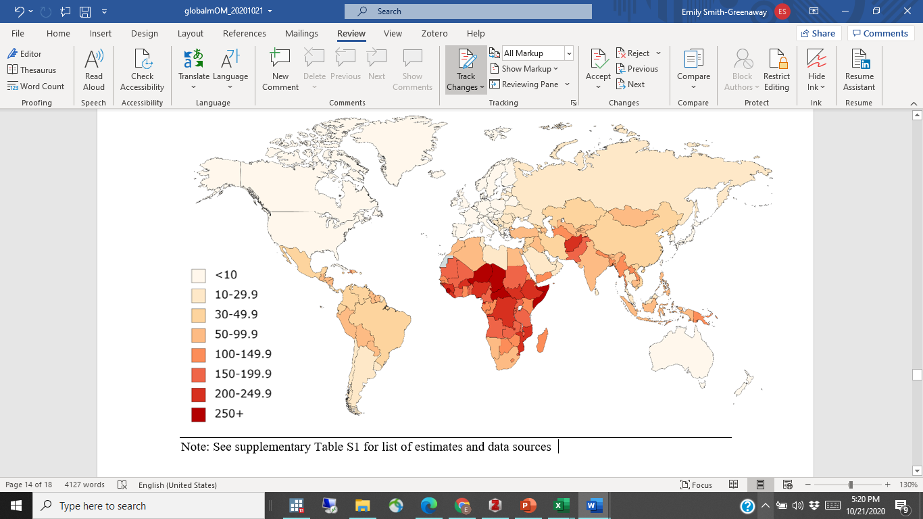

Note: See supplementary table S1 for list of estimates and data sources

**Figure 2. Maternal cumulative prevalence of infant mortality (mIM) for mothers age 45-49**

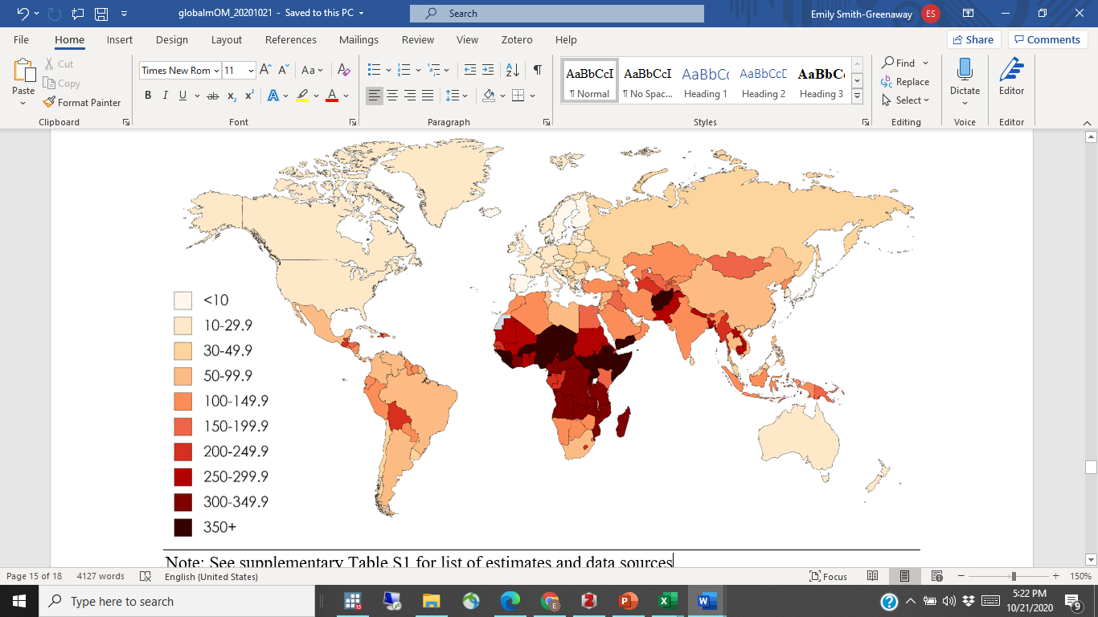

Note: See supplementary table S1 for list of estimates and data sources

**Figure 3. Maternal cumulative prevalence of under 5 mortality (mU5M) for mothers age 20 to 44**

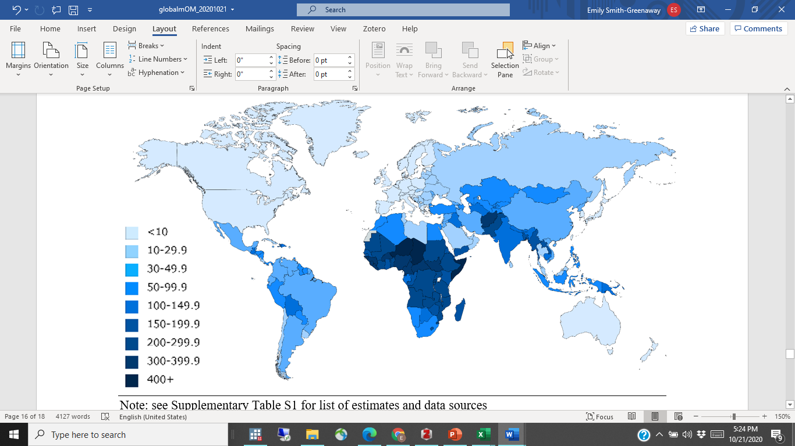

Note: See supplementary table S1 for list of estimates and data sources

**Figure 4. Maternal cumulative prevalence of under 5 mortality (mU5M) for mothers age 45-49**

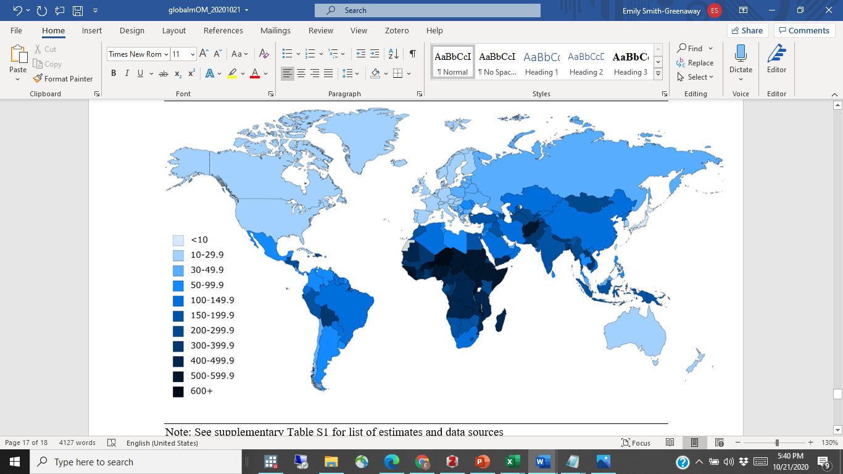

Note: See supplementary table S1 for list of estimates and data sources

**Figure 5. Maternal cumulative prevalence of offspring mortality (mOM) for mothers age 45 to 49**

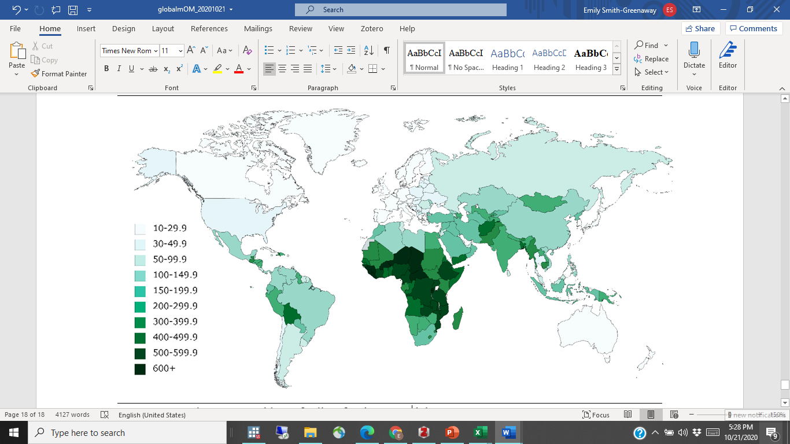

Note: See supplementary table S1 for list of estimates and data sources